Anni Simpson
Dr. Jason Swarts
ENG 519
March 16, 2015
Forum Moderation Paper
INTRODUCTION
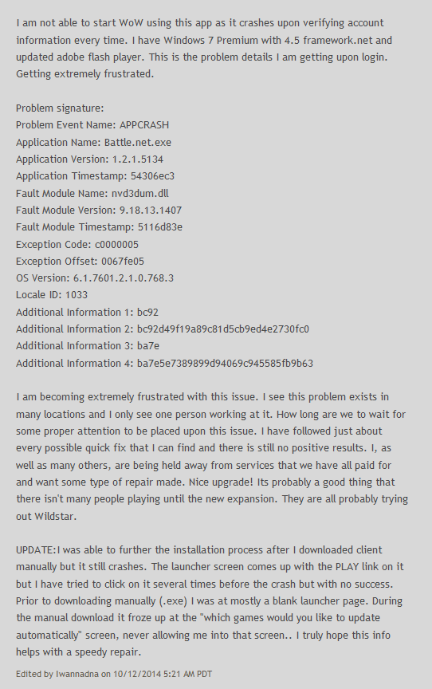
Blizzard separates their technical support forums by the applications they support, but I chose the catch all “Battle.net” technical support forum, which handles issues related to the overall launcher – the application that connects all others. The launcher is available for Mac OS and Windows, as well. As a result, the tech support forums handle a wide array of issues that have an equally diverse set of potential fixes. Because I use this app myself and four of the five games supported, this is a forum I’m personally very familiar with and have posted independently of this class.
Figure 1
All examples were pulled from the front page of the forum.
COMMON USES FOR THE FORUM
By and large, the most common problem was something to the effect of “Battle.net app doesn’t work.” Another common complaint on the forums were that the application wouldn’t update. It was not typical to see users list their specific scenarios, the operating system they were using, or any other vital details. The important details were left by the original poster (OP) in the initial message. Using an example from October on “Battle.net app has stopped working” which is still one of the top complaints, OP Iwanadna included the problem, the specs to his system, and the game he was playing (World of Warcraft) (Figure 1).
A similar forum post, “New Comp freezing while trying to install WoW,” contains the same sort of situation: a generic problem title that points to issues with the Battle.net launcher and WoW, a longer post expressing frustration, and a list of system specs to help identify the issue. The only major difference between these two posts are the fact that the first post referenced had a much larger response from the forum community. The reason seems to be the fact that, according to user Hayseed, is that the issue has been “a problem for 6-8 months and it doesn't get any better” with comments as recent as Feb. 27, 2015.
In “Battle Net App - Error: BLZBNTBGS80000021,” the post deviates from the “genre” in this forum community by naming a specific error, although still not describing what the error does. So the post itself still remains generic. Like the previous two examples, it names the general problem, some circumstances (“since the 6.1 wow patch,” “internet is running fine,” etc.). Something else OP Ryukken does that others don’t always do is name the things he or she has tried to do already including “resetting my DNS server/router” and “multiple PC restarts.” The post garners a smattering of responses (two pages of replies), some affirming the problem
In many of the threads (including my first and third examples), some of the purpose of the reply function seems to be to affirm the issue is not necessarily user error. Others comment in to say they have also experienced the issue and don’t have a fix but need one. Because this particular forum doesn’t send email or status messages to say when your threads have been replied to, there doesn’t seem to be a purpose to “bumping” a thread just for updates. That only really leads the affirmation to underscore how important a fix might be. The second example garnered no replies at all, so it’s hard to tell what the response would have been.
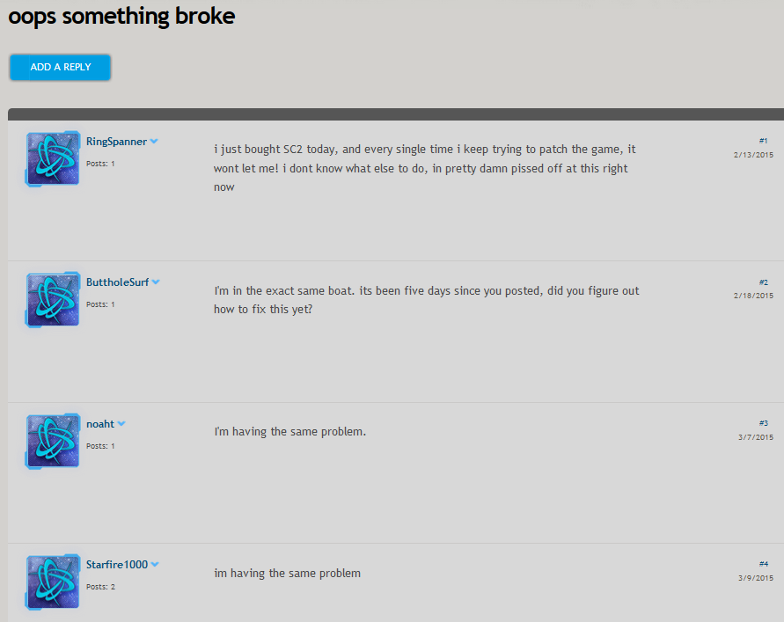
Another common use for forum users seems to be the fact that it can enable users to air their frustration whether or not anyone sees a proposed solution. In “oops something broke,” OP RingSpanner doesn’t follow the pattern of other users looking for technical solutions. Keeping to the convention of a vague title, they follow the content of their post with vague descriptions, underscored by comments of frustration: “in pretty damn pissed off at this right now” (Figure 2). The user in the example doesn’t give enough technical details to pinpoint an issue but rather rage at Blizzard for what appears to be their perception that they have created a defective product. You can tell that’s where RingSpanner is going by using the ohrase “every single time I try to patch the game.” Although we have a sort of understanding of the circumstances (patching; playing StarCraft II), that’s it. More words are dedicated to his unhappiness than at his attempt to fix the issue.
Figure 2
In another example, “have not been able to connect to battle.net for over 2 weeks,” the user spends the title making sure to illustrate how unacceptable their situation is rather than the generated error code, which is listed out of any sort of context within the tread itself. Their frustration is exemplified with phrases including “this wont stop” and “kinda bummed about this.” While they request a fix for the situation, a later poster, Velnrak, has to request, “Can you tell us more about your connection?” Then and only then does the OP elaborate that he is using a “wireless” connection using Windows OS, Windows Firewall, AVG, and a D-Link DWA-182 adapter, information that was typically relayed early on in other posts where the poster appeared to be looking for answers instead of to vent.
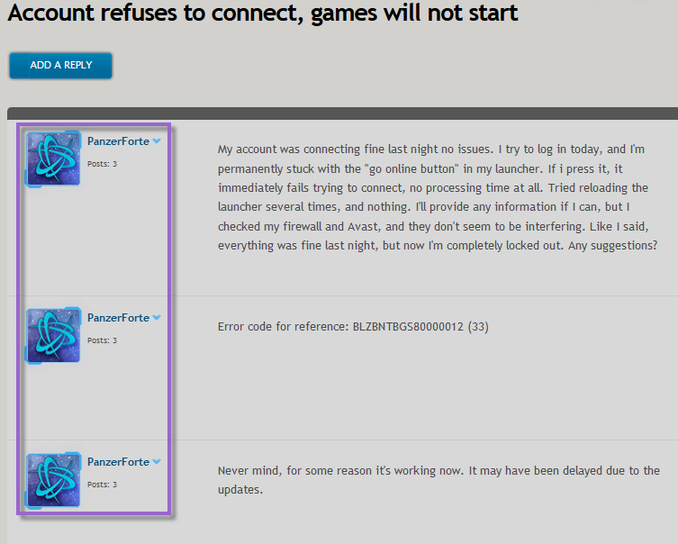
In one final example, OP PanzerForte made a thread “Account refuses to connect, games will not start” that was intended to complain that they were “permanently stuck with the "go online button" in my launcher.” What’s interesting about this case – and supports the “forum as a place to vent” space – is that they gave no details, no specifications, no use case, no actual troubleshooting steps aside from checking their firewall, and no attempt to interact with the knowledge base. They add the error code for reference later, and then they again update the thread to say the issue was resolved. These statuses appear within a single day (Figure 3). They use interesting language like “refuses” (granting the application agency), “permanently” (insinuating unfixable), and “like I said” (repeating that they have a frustrating problem out of their hands). They do not bother to take down the thread, however. Nor do they add a solution that worked for them – just that the problem resolved itself.
Figure 3
Finally, a third major intent for the forum was affirmation. In every example above with users who received replies (other than themselves..), there were other users present affirming that they too had the same issue.
In “My B.NET launcher seems to have chosen the wrong warcraft account to log into,” OP TimFakeknee complained that he had “difficulties with launching the proper account for WoW” where the game launches to my starter account that I had made and not my MoP account.” The thread itself was created on November 13, 2013. Note that MoP (Mists of Pandaria) is not even the latest expansion; Warlords of Draenor was released in November 2014. However, the thread continues to cultivate replies in the form of affirmations, the latest being mEKamoney, who said, “Same issue here was fine last night” on Feb. 25, 2015. No one actually responded to the thread with a fix.
RESPONSES TO QUESTIONS/PROBLEMS
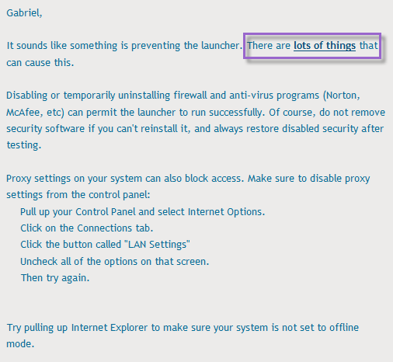
There are two major types of solutions proposed when users report a problem:
Figure 4
- Official knowledge base articles are suggested, which often contain catch-all troubleshooting links (Figure 4). These are almost always posted by Support Forum Agents (or official moderators), which I will get to later in the paper. In “Battle.net client problem,” moderator Jurannok linked to an article that handled patching problems.
These are often more complicated “tame” problems that look more complex than they really are with official fixes.
- “Potential” solutions that may or may not have worked for others. In these cases, the fix for wicked problems that had no official solution dictated by a moderator or even forum MVP. Instead, random posters who may or may not post often will suggest fixes based on their generalized experience with Blizzard products, other software, Battle.net or other Blizzard games more specifically, or their generalized IT background. If the suggested fix doesn’t work, others may or may not pitch in to suggest other possible solutions, often workarounds rather than official solutions.
In “reaper of souls,” OP nomis36 was unable to install the Diablo III expansion, Reaper of Souls, from the CD using his CD key. While moderatort Jurannok posted to let him know Reaper of Souls was already tied to his account and so there was no problem, others popped in to complain that they also had the same issue. Eventually, poster SgtMajor (who has only ever posted once) was able to inform the users involved in the thread they were using the incorrect base edition of the game. This was later confirmed by Jurannok, but it was a more complex “if then” solution than the moderator was expected and relied on outside information that heavily impacted the proposed solution.
In that example, the fix actually ended up solving the issue for others who had originally affirmed the issue, not just nomis36. The wicked fix was beneficial for multiple people all at once but only after an actual discussion involving multiple people was generated.

INTERACTING WITH THE FORUM
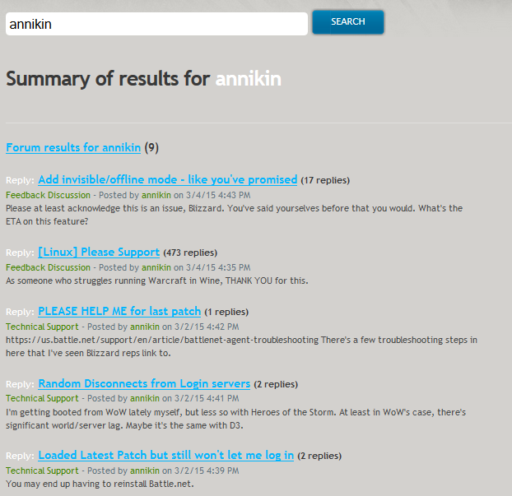
I tried to no avail to interact with this community. Unlike some others in the class, this wasn’t because the forum was dead but perhaps oversaturated with comments from other people in a continual cycle all day every day. Even though the first post was actually from October 2014, it had continued activity on it until this week, because the issue (and for some reason that specific thread) persisted.
Figure 5
Something I found interesting is that even though I tried approximately 11 times to interact with the community that I couldn’t even find my own posts on Battle.net consistently. Prior to the paper, I searched my own username and found three results. For the paper itself, I searched my name and found nine – still below the number of posts I’d made (Figure 6) . However, I had tried 11 times for this project. Some of the results were much older, meaning more recent posts I’d made on my own time prior to the beginning of the semester were returning. I found that my assumption was correct; one example in particular where I complained about a user interface change to a game in alpha still returned, meaning more recent posts had not. Google returned 24 results by comparison (Figure 5). Some of these results were repeats – clearly – but they contained a better history than the one Battle.net kept, prompting me to wonder if my replies were even being seen by the majority of users.
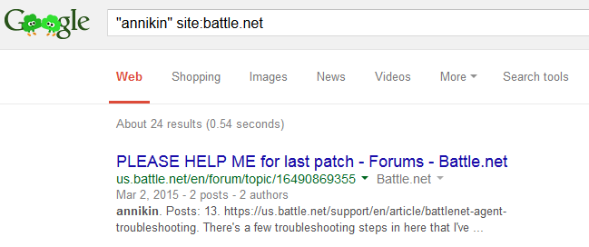
In forums where there were replies after myself, no one interacted with me specifically. They either affirmed the issue alongside myself or ignored my replies, which tended to include basic troubleshooting steps like “have you tried reinstalling the program?” or “have you attempted to reset your Internet connection?” I took these troubleshooting steps from others I’d seen suggested by actual Blizzard representatives or forum MVPs. However, as I said, no one replied.
Figure 6
Whether a post got traction seemed entirely random given that some of the threads being replied to were from last year or even the year before. Others were freshly posted. Some had as few as 0 comments. On the front page, the most replies any actual thread received were 191 (stickied). For non-stickied threads, there highest number of replies a post on the front page received was 91. I’m guessing the algorithym took into account both number of views (ranging from five to 4493/non-stickied or five to 15,238/stickied) and replies, as well as how new a forum post was.
POSTERS
There are three kinds of posters in the Battle.net forums:
- Moderators, otherwise called Support Forum Agents who act as official representatives of Blizzard. They are marked by their “Support Forum Agent” title, the blue text of their responses, and the “Blizz” logo to the right of every comment they make (Figure 7). They exude an ethos of professionalism in their ties to Blizzard.
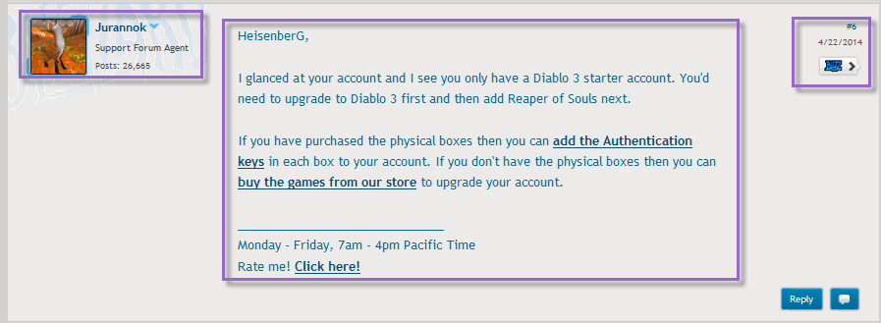
- MVPs, otherwise called MVP – Technical Support. They are not official representatives but are trusted members of the community. They are marked by their green text. They exude an ethos of trustworthiness by their specialized status, as well as the sheer number of times they’ve posted.
Figure 7
- Regular posters. They have gray text, and they are not marked in any specialized way. They rely on logos (correct information), ethos () and pathos outside of the official Blizzard community. They can improve their own status by posting frequently, having highly rated comments, or by simply providing valuable information.
Something interesting about these roles is that the highest grouping of poster, the Support Forum Agents, have the strongest sense of ethos in the community due to their standing at Blizzard but don’t provide the most effective troubleshooting support. Their presence is coveted, but their support is almost always limited to linking to knowledge base articles and checking individual accounts. (For starters, why aren’t problems like that covered by opening individual tickets to ensure private information on each account is protected?) However, they don’t provided targeted or specific advice to an individual user with a complex, edge case or otherwise wicked problem.
Those who tackle wicked problems appear to be MVPs and regular posters. MVPs are those who have replied to threads hundreds – in some cases thousands or tens of thousands – of times with responses. Many of the responses by MVPs are tailored to specific scenarios and may include more complex troubleshooting steps than, “Did you try reinstalling the program? What about resetting your router?”
Regular posters were far more likely to affirm problems or frustration, but in some cases, they weighed in themselves to say that not only had they experienced a similar problem but had also fixed it by using a specific methodology.
CONCLUSIONS
The Battle.net forum posts were a cluster of competing, difficult-to-comprehend information. Many users arrived with very specific problems with computer specificiations, while others arrived with more general problems that may or may not have been out of their control considering how long some of the bugs in the above examples had lasted (2014 and 2013). Not to mention that there were multiple tiers of posters, as well as the inability to find all of my individual posts to see who’d replied to what.
I also felt like because I hadn’t received much (if at all) attention in my responses, some of which were troubleshooting suggestions, the Battle.net forums weren’t necessarily the best place to glean information. Wicked problems were the ones that were tackled by non-moderator posters, and the moderators were already utilizing official information from their knowledge base. In other words, the information moderators offered weren’t new, and the information that was seemed to be so specific to individual users that other methods of support (phone, ticket, IM) may have worked instead.
Like the wiki, this was a moderately disappointing experience. There was indeed a wealth of information available, but it took combing through pages and pages worth of information to find troubleshooting steps that worked in some cases, if at all.
However, the presence of everyone involved seemed supportive rather than negative. No poster seemed to be there to troll others or to cause grief. The supportive nature of the community was its saving grace, but it couldn’t outweigh the biggest concern of the forum which was that it was so large that it became unwieldy.

Works Cited
“Account refuses to connect, games will not start.” Battle.net Technical Forum. Blizzard Entertainment.
10 March 2015. Web. 11 March 2015. http://us.battle.net/en/forum/topic/16543164807
“Battle Net App - Error: BLZBNTBGS80000021.” Battle.net Technical Forum. Blizzard Entertainment. 26
Feb. 2015. Web. 10 March 2015. http://us.battle.net/en/forum/topic/16410481931
“Battle.net app has stopped working.” Battle.net Technical Forum. Blizzard Entertainment. 10 Oct. 2014.
Web. 10 March 2015. http://us.battle.net/en/forum/topic/14731003851
“Battle.net client problem.” Battle.net Technical Forum. Blizzard Entertainment. 10 March 2015.
Web. 12 March 2015. http://us.battle.net/en/forum/topic/16543664857
“have not been able to connect to battle.net for over 2 weeks.” Battle.net Technical Forum. Blizzard
Entertainment. 4 March 2015. Web. 11 March 2015.
http://us.battle.net/en/forum/topic/16543574229
“My B.NET launcher seems to have chosen the wrong warcraft account to log into.” Battle.net Technical
Forum. Blizzard Entertainment. 13 Nov. 2013. Web. 10 March 2015.
http://us.battle.net/en/forum/topic/10490649802
“New Comp freezing while trying to install WoW.” Battle.net Technical Forum. Blizzard Entertainment.
13 March 2015. Web. 13 March 2015. http://us.battle.net/en/forum/topic/16647914648
“oops something broke.” Battle.net Technical Forum. Blizzard Entertainment.
13 Feb. 2015. Web. 11 March 2015. http://us.battle.net/en/forum/topic/16354555293
“reaper of souls.” Battle.net Technical Forum. Blizzard Entertainment. 27 March 2014. Web. 12 March
2015. http://us.battle.net/en/forum/topic/12296589617

